Project Design Phase-II
Data Flow Diagram & User Stories

Date | 05 October 2026
Team ID | SWTID-2026-4458
Project Name | Import Data using Transform Maps (Spreadsheet)
Team Leader | Monika B
Team Members | D Keerthana, Chandhana S, Vemalaraju Poojitha, Subasri R
Maximum Marks | 4 Marks

Data Flow Diagrams:
A Data Flow Diagram (DFD) is a traditional visual representation of the information flows within a system. A neat and clear DFD can depict the right amount of the system requirement graphically. It shows how data enters and leaves the system, what changes the information, and where data is stored.

Example: (Simplified)


Our Data Flow Diagram: Spreadsheet Import using Import Sets & Transform Maps
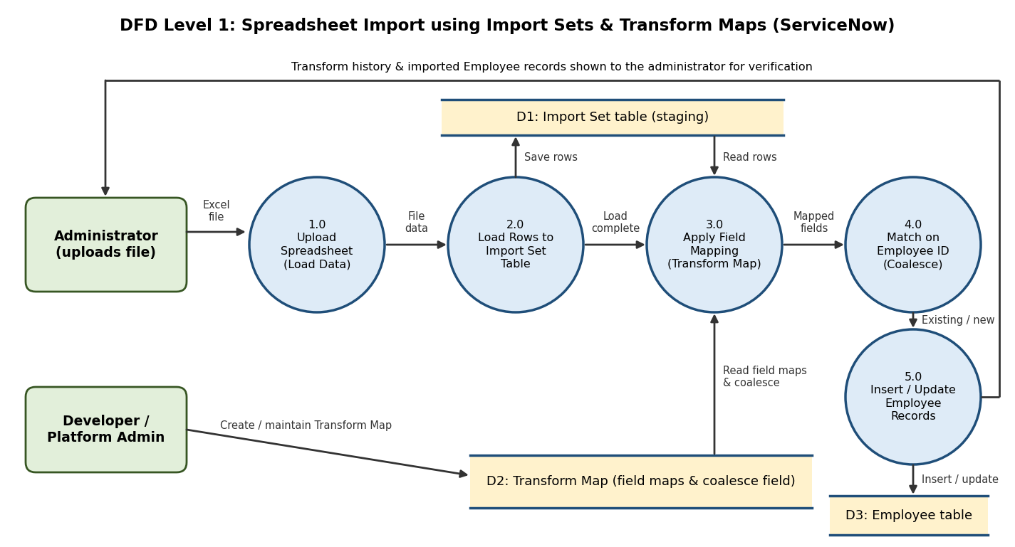

User Stories
Use the below template to list all the user stories for the product.
User Type | Functional Requirement (Epic) | User Story Number | User Story / Task | Acceptance criteria | Priority | Release
ServiceNow Administrator | Data Loading (Import Set) | USN-1 | As a ServiceNow administrator, I can upload an Excel spreadsheet using Load Data, so that employee data enters ServiceNow in bulk. | The file uploads and an Import Set table is created with the spreadsheet columns | High | Sprint-1
 |  | USN-2 | As an administrator, I want the spreadsheet rows stored in an Import Set table, so that the data is staged and checked before it reaches the live table. | All rows appear in the Import Set Rows list | High | Sprint-1
 |  | USN-3 | As an administrator, I can review the loaded rows against the spreadsheet, so that missing or wrong rows are found early. | Row count in the Import Set table matches the spreadsheet | Medium | Sprint-1
 | Field Mapping (Transform Map) | USN-4 | As an administrator, I can create a Transform Map from the Import Set table to the Employee table, so that the data goes to the right target. | Transform Map exists with the correct source and target tables | High | Sprint-1
 |  | USN-5 | As an administrator, I can map Employee ID, Name, Email, Department and Location to the Employee table fields, so that each value lands in the correct field. | All five fields appear in the Field Maps list with the correct targets | High | Sprint-1
 | Record Matching (Coalesce) | USN-6 | As an administrator, I can set Employee ID as the coalesce field, so that existing employees are updated and new employees are inserted without duplicates. | Same Employee ID updates the existing record; a new Employee ID creates a new record | High | Sprint-1
 | Verification & Reporting | USN-7 | As an administrator, I can run the transform and view the transform history, so that I know how many records were inserted, updated or ignored. | Transform history shows the counts and no unexpected errors | High | Sprint-2
 |  | USN-8 | As an administrator, I can open the Employee table and compare records with the spreadsheet, so that the imported data is verified as accurate. | Sampled records match the values in the spreadsheet | Medium | Sprint-2
 |  | USN-9 | As an administrator, I can view reports and a dashboard on employee data by department and location, so that the imported data is easy to analyze. | Reports and the Employee Analytics Dashboard show data from the Employee table | Medium | Sprint-3
Data Owner / HR | Data Quality | USN-10 | As a data owner, I want my employee details imported correctly with no duplicates, so that the employee list I rely on stays accurate. | Each Employee ID appears once and values match the source spreadsheet | Medium | Sprint-2
Developer / Platform Admin | Configuration | USN-11 | As a developer / platform administrator, I can add, edit or remove field maps without writing code, so that mappings can change when the spreadsheet columns change. | Changed field maps take effect on the next transform | Medium | Sprint-2
 |  | USN-12 | As a developer / platform administrator, I can move the Transform Map to another instance using an Update Set, so that changes are controlled. | Update Set contains the Transform Map and loads without errors | Low | Sprint-3

